Testing Document  
*UWA Biosecurity Game*  
By: Joel Dunstan  
Email: [jd427244@gmail.com](mailto:jd427244@gmail.com)  
biosecurity.are.uwa.edu.au

Table of Contents

Objectives and Test Summary 3

Testing Strategy 3

Automated Testing 3

Hardware and Manual Testing 5

Test 1: The Frequency of Outbreaks 5

How an Outbreak is Determined 6

Test Specification 7

Test Description 7

Test Analysis Report 8

Test 2 – Automated Command Line Testing 12

Test Specification 12

Test Description 12

Test Analysis Report 13

Test 3 – Automated Browser Bot Testing 16

Test Specification 16

Test Description 17

Test Analysis Report 19

Test 4 – Manual Browser Testing 20

Test Specification 21

Test Description 21

Test Analysis Report 25

Test 5 – Server Performance 25

Test Specification 25

Test Description 25

Test Analysis Report 25

Test Materials 26

oTree_Tags 26

Glossary 28

References 28

**Objectives and Test Summary**

This document is primarily focusing on testing all aspects of the system, web site and the program underlying the website biosecurity.are.uwa.edu.au. Here it will describe the behaviour of the system and the underlying logic that decides when outbreaks occur. Testing will primarily focus on these aspects:

1) How outbreaks are determined and the amount of times outbreaks occur.  
2) The general usability and functionality of all the pages and how they work together  
3) The websites compatibility across systems, web browsers especially due to its use of HTML5 specific code used within the webpages, and its use of Django, a Python framework.  
4) The performance of the server, its backup strategies and recovery plans (if any can be done). Focusing on how many users the server can handle and creating a session and running a session with many participants, 100 being the acceptable amount.  
5) The export of the data from each game for experimental purposes and its readability.  
6) The full use of all these aspects all working together in one cohesive, usable system even by users who aren’t fully familiar with python programming

**Testing Strategy**

The Testing Strategy will be divided into two areas depending on what needs to be tested. One being Automated Testing which will be primarily used for Software Testing, however Automated Testing will be used when testing the server’s capabilities as browser bots can be used to mimic user behaviour on the website.

The overall strategy is a bottom-up approach test the bare code itself, using the command line as a way to test this (Refer to Automated Testing for more detail), from here I will move on to using browser bots to ensure that logic works within a web browser as well (While checking its compatibility with web browsers). Finally, I will conclude with running the game manually myself in each browser.

Changes made to the code will be documented inside each test’s results.

### Automated Testing

Automated Testing will be used in just about all areas of testing using the tests.py from every application inside the oTree Project, the project was divided into three applications, Lottery Game, Biosecurity, and Results. These tests can be run inside the command line using oTree test <session_config_name> using numbers as arguments to conduct tests with a different number of participants. An example of such a test would be *otree test basic_biosecurity_test 4* which means that the command line will use the test.py from the application Biosecurity and run the session configuration ‘basic_biosecurity_test’ using 4 participants.

The automated tests do verification checks to see if the game produces the correct results given costs, player approvals, etc. If the game completes a test, then it indicates that the game ran without an AssertionError which in oTree occurs whenever an assert statement failed or a game failed to finish due to oTree having no progress in the game (it doesn’t progress to the next page with a form). In the case of a test being completed successfully then this will appear on the command line at the end of the test:

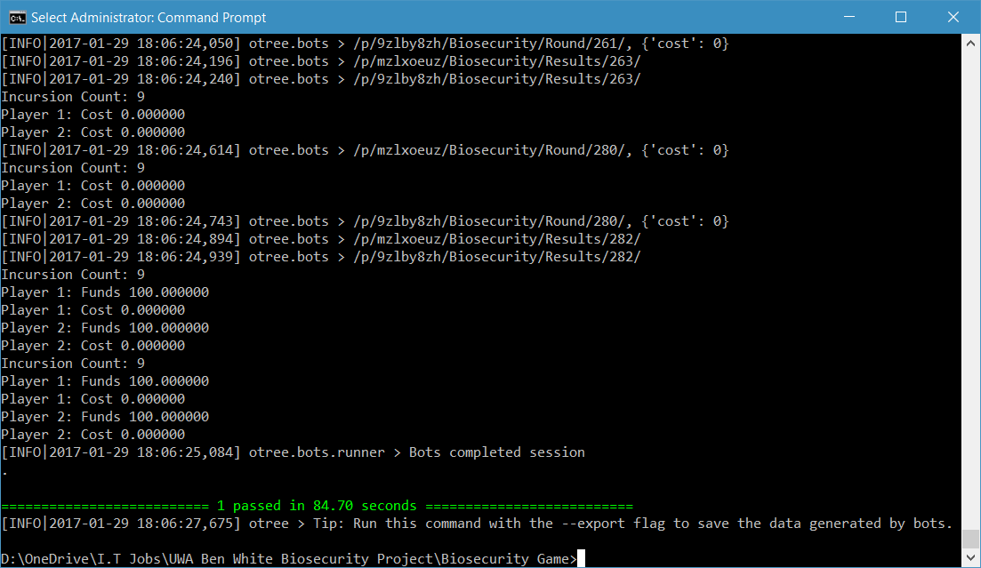

For the Lottery Game, automated testing will always double check that the quiz for testing people’s understanding of the game is working correctly giving an incorrect answer to see if it will fail, and then giving the correct answers. For the actual Lottery Game, itself, it randomly chooses A or B for the forms to make sure the data goes in through the form as there is no real way to verify that a person gets an exact result, due to the randomness of the selection of the winning game for every single session.

Focusing on the Biosecurity Game, automated testing conducts itself using different scenarios, the first being random where for every single form it produces a random value and performs checks on these values by replicating the same equations used in the code of the game and then comparing the results of the game with the results of the test using assert statements. To be specific the values that are tested throughout the game are the costs of protection for every single round, the funds at the end of each round, any group pledges that were performed, and finally the approvals by players. In the random scenario, we use random values for every single form required. The automated tests conduct other scenarios in the order mentioned below, which each scenario will show the values used for each of the values being tested above:

Quarter: 25% Max Protection for the cost of protection, funds are dependent on whether there was an outbreak or not and hence random and will not be mentioned further, group pledging is done randomly and the approvals are always -6.

Half: 50% Max Protection for the cost of protection, group pledging is done randomly and approvals are always 3.

Three-Quarters: 75% Max Protection for the cost of protection, group pledging is done randomly and approvals are always done at 6.

Full: Max Protection for the cost of protection, group pledging is random and approvals are always 0.

Half0HalfFull: Half of the bots do Max Protection, while the other half do no protection whatsoever, group pledging and approvals are random.

Bankrupt: No protection at all, group pledging and approvals are random.

There are default values used for every test throughout, the maximum amount of protection that can be used is always 15, the cost of upkeep is always 5, the revenue is always 25, the starting amount for every player is 25, the minimum amount of chance that someone is not the source of the outbreak is 60% (refer to Test 1: The Frequency of Outbreaks), the number of participants is 4 which all participants are all in a single group. Finally, a pledging round comes every 3 rounds and every round is when an approval by contribution takes place.

Finally, the Results has a survey to which each bot automatically completes and just waits for correct pages to come forth.

The same code that lies within the test.py for every application that does the command line testing also does the browser bot testing and therefore it’s safe to conclude that if a browser bot test completes without a fault, then the game’s logic is compatible with the browser.

### Hardware and Manual Testing

The manual testing will involve simply running the game manually instead of having automated tests complete the game. Manual Testing will be heavily used during compatibility testing to verify that each form works as we expect in each web browser. Manual Testing will include verifying the data that oTree produces every time a session is run, this will be the least tested part of the entire program as it simply loads data from a database which I don’t have much control of as oTree by design puts all the data inside the database by design without me as a user specifying every single round that I want to store the data.

Hardware testing will be conducted to see how the server performs under load. To put strain on the server I will conduct tests with automated testing and large amounts of participants. Doing this will mimic how the server will behave when so many participants are all on the server playing each game all at once. It’s here that major changes to the amount of resources the server has available will be documented. No other Hardware testing is required here, as I have no good means of backing up the database that will contain the data for all the sessions on a separate machine to the server, hence testing of the backup solutions will be restricted to getting any backups stored on the server itself.

## Test 1: The Frequency of Outbreaks

The first iteration of the biosecurity game took an average of everyone’s protection and then generated a random number, and if the random number was higher than this, then an outbreak would occur. However, in this iteration, we now take a joint probability, this meant that calibration was needed to see the frequency of outbreaks and how participants would fare in different conditions depending on how they decided to play. In an ideal game where everyone was cooperative, there would be at least 3-5 outbreaks with participants gaining a profit. In contrast, if participants weren’t cooperating then there would be at least 8-15 outbreaks depending on how uncooperative they were and a loss from the starting amount of $25, with the potential of a small bankruptcy (up to $10 in debt). This test involved changing the maximum amount of protection against biosecurity threats a player could provide in each round and the probability coefficient, or the minimum probability that a player is **not** the source of the outbreak. Before describing how I conducted the test, one should know how an outbreak is determined, and what happens when an outbreak occurs.

### **How an Outbreak is Determined**

**MP** = **Max Protection =** (The maximum amount of protection a participant can put against biosecurity threats)  
  
**PC =** **Probability Coefficient =** (Essentially we moved the graph up so that $0 worth of protection doesn’t result in a 100% chance that someone is the source of the outbreak, e.g. if PC = 0.4, then there is a 40% chance that someone is **not** the source of the outbreak, or 60% chance that they’re the source of the outbreak)  
  
**C = Amount of protection a player put in that round** ($0 ≤ P ≤ MP)  
  
**P1, P2, P3, P4 = The probability that a player (4 players in this scenario) is NOT the source of the outbreak** (0 ≤ P1, P2, P3, P4 ≤ 0.999). Will be denoted as **Px** when referring to the function for P1-4.

**RAND =** A random number between 0 and 1 generated by the server

**U =** The cost of the crops per round  
  
**R =** Revenue which a player receives when there is no outbreak  
   
1) Get the Cost Factor:

**CF = $-\frac{MP}{ln(1-0.999+PC)}$**

2)Determine the probability that a player is the source of the outbreak:

**Px =**3)Determine the probability of no outbreak for the group (the set of players containing P1­ – P4):

**Probability of No Outbreak (PNO) = P1** x**P2** x**P3** x**P4**

4) Determine the probability of an outbreak for the group:

**Probability of an Outbreak (PO) = 1 – PNO**

5) Now generate a random number between 0 and 1 and follow the inequalities below:

**if PO > RAND, Outbreak Occurs**

**if PO < RAND, No Outbreak Occurs**

6) Now determine each player’s profits or losses as per the following functions:

If there was an Outbreak, then: **Current Funds = Current Funds – C – U**

If there was no Outbreak, then: **Current Funds = Current Funds – C – U + R**

### Test Specification

In this test, we require seeing that the group’s actions proportionally affect how much the group the gains from the game. That means:

*As a group if each player is cooperative, then we must see that on average, each player should receive a sizable profit compared with starting amount, while still having outbreaks to prevent a lack of engagement from the game being too easy and the result being independent to the group’s actions.*

*Inversely, as a group if each player is uncooperative, then we must see that on average, each player should receive a loss from the game compared with the starting amount, while still allowing players to ideally to finish with an amount more than $0 to prevent lack of motivation and engagement in the game***.**

It is worth mentioning too, that while the above is a requirement, it won’t always be met due to the nature of joint probability and some of the inherent randomness in the game. The game should allow cases where players are *cooperative* and outbreaks still occur often. Inversely, the game should also allow cases where players are *uncooperative* and outbreaks don’t occur often. Such cases in this game should be rare though to get the best data possible, as the player’s actions must determine the outcome as much as possible despite the randomness that exists in the game.

### Test Description

To perform this test, you will need a terminal (CMD, Bash) where you will be able to perform the command line tests and export the data to an accompanying file (ideally, text, csv something readable by humans). The operating system you use, shouldn’t matter as long as you have a met these requirements (at the time of writing 02/04/2017):

oTree 1.2.8 (or above)  
Postgres 9.6.1 (or above)  
otreechat (latest version)  
psycopg2 (latest version)  
Python 3.6 (or above)  
  
Have followed the instructions for oTree to use Postgres as per this page:  
<http://otree.readthedocs.io/en/latest/server/ubuntu.html#database-postgres>

Postgres here isn’t completely necessary to complete these tests, you could theoretically use MySQL, MSQL (Microsoft SQL) and many others, you must ensure it’s a Relational Database that can withstand multiple concurrent transactions without issue.

And finally refer to here for the note on otree_tags:

oTree_Tags

In the terminal (in my case PowerShell), you’ll need to put the following command to perform the test 20 times for the sake of getting a reasonable sample size to reduce the average being affected by any outliers like those rare times when players do well despite being uncooperative or vice versa.  
  
for($i=1; $i -le 20; $i++) {

otree test basic_biosecurity_test 4 > “Path\To\File\file<i>.txt”

}  
  
This will run the basic biosecurity test 20 times which includes all the different case scenarios which were as follows (and in the order, they will be performed):

* Random
* Quarter
* Half
* Three-Quarters
* Full
* Half0HalfFull
* Bankrupt

For more details on what these scenarios include refer to Automated Testing. The above code will also produce text files which you will need to record the incursion count and the funds each player has at round 5 and the end of the game. How you the reader record these, I will leave to you, my method was to record the data into Excel Spreadsheets which automatically calculated the average and mode of outbreaks (denoted as incursions in my documents as there was a change of terminology) and funds at rounds 5 and 15.

While you may not produce the exact same results due to the randomness of the game and the changes that were made while testing the frequency of outbreaks, you should be able to make the same conclusion as I did below.

### Test Analysis Report

In the tests, there was two values that changed throughout the tests which were:

1. The minimum chance that a player wasn’t the source of the incursion, or the **Probability Coefficient (PC)** as per How an Outbreak is Determined.
2. The Maximum amount of protection or effort that a player can put against biosecurity threats, or the **Maximum Protection (MP)** as per How an Outbreak is Determined.

The reason that these values were adjusted is because these values adjust the frequency of outbreaks and how much funds each player finished with more than any other values. While one could adjust the revenue each player, $25 is a good value as a player can gain that amount and just as easily lose it with carelessness, any higher the game would be too easy, any lower too hard. As one will see from my results the same rings true for both **PC** and **MP**.

The defaults across all games were as follows:

* $5 for Upkeep **(U)**
* $25 for Revenue **(R)**
* 4 Participants
* $0 as the Minimum Amount of Protection
* 15 Rounds, thus we take the averages below as the average number of outbreaks occurring within 15 rounds.
* The Starting Funds is $25 for every player.

**The Average Frequency of Outbreaks**

|  |  |  |  |  |  |
| --- | --- | --- | --- | --- | --- |
| Scenario ↓ | **MP PC →** | **MP =** $15 **PC =** 40% | **MP =** $15 **PC =** 50% | **MP =** $10 **PC =** 60% | **MP =** $10 **PC =** 70% |
| Random | | 10.25 | 9.2 | 7.9 | 6.4 |
| Quarter | | 13 | 12.05 | 10.95 | 8.7 |
| Half | | 9.7 | 8.65 | 8 | 6.4 |
| Three-Quarters | | 5.6 | 5.45 | 4.45 | 3.65 |
| Full | | 0 | 0.05 | 0 | 0 |
| Half0HalfFull | | 12.75 | 11.35 | 9.7 | 7.8 |
| Bankrupt | | 14.8 | 13.6 | 13.1 | 11.9 |

**Mode - Frequency of Outbreaks**

|  |  |  |  |  |  |
| --- | --- | --- | --- | --- | --- |
| Scenario ↓ | **MP PC →** | **MP =** $15 **PC =** 40% | **MP =** $15 **PC =** 50% | **MP =** $10 **PC =** 60% | **MP =** $10 **PC =** 70% |
| Random | | 10 | 10 | 9 | 6 |
| Quarter | | 12 | 13 | 12 | 9 |
| Half | | 8 | 9 | 7 | 7 |
| Three-Quarters | | 4 | 5 | 4 | 3 |
| Full | | 0 | 0 | 0 | 0 |
| Half0HalfFull | | 13 | 12 | 10 | 6 |
| Bankrupt | | 15 | 13 | 14 | 13 |

**Average Funds at Round 5 - Frequency of Outbreaks**

|  |  |  |  |  |  |
| --- | --- | --- | --- | --- | --- |
| Scenario ↓ | **MP PC →** | **MP =** $15 **PC =** 40% | **MP =** $15 **PC =** 50% | **MP =** $10 **PC =** 60% | **MP =** $10 **PC =** 70% |
| Random[1] | | 5.26 | 11.30 | 43.51 | 47.93 |
| Quarter | | 0 | 3.75 | 23.75 | 48.75 |
| Half | | 6.25 | 7.5 | 40 | 36.25 |
| Three-Quarters | | 25 | 20 | 52.5 | 60 |
| Full | | 50 | 50 | 75 | 75 |
| Half0HalfFull[2] | | -15 | -15 | 16.25 | 49.38 |
| Bankrupt | | 1.25 | 8.75 | 16.25 | 25 |

**Average Funds at Round 15 - Frequency of Outbreaks**

|  |  |  |  |  |  |
| --- | --- | --- | --- | --- | --- |
| Scenario ↓ | **MP PC →** | **MP =** $15 **PC =** 40% | **MP =** $15 **PC =** 50% | **MP =** $10 **PC =** 60% | **MP =** $10 **PC =** 70% |
| Random[3] | | -43.525 | -19.18 | 52.46 | 92.45 |
| Quarter | | -56.25 | -32.5 | 13.75 | 70 |
| Half | | -30 | -3.75 | 50 | 90 |
| Three-Quarters | | 16.25 | 20 | 101.25 | 121.25 |
| Full | | 100 | 98.75 | 175 | 175 |
| Half0HalfFull[4] | | -106.25 | -71.25 | 7.5 | 48.13 |
| Bankrupt | | -45 | -15 | -2.5 | 27.5 |

Going through each test, first starting with **MP** at $15 and the **PC** at 40%, it was clear in these scenarios that with **PC** at 40% the game was too harsh. Even if every player contributed at 75% of **MP** ($11.25) every single round, then on average everyone would still have less than what they started with. While it was possible to finish with a profit, the optimum amount of protection to ensure this all the time was around $13 or 90% chance that a player is not the source of the outbreak.

The story was the same with **PC** at 50%, while the game was less harsh, it still had an unacceptable result at Round 15. If every player contributed 75% or $11.25 every round, then players would still lose $5 compared to the starting amount. With **PC** at 50%, there was notable improvements compared to 40%, on average there was one less outbreak in each scenario and it was now possible to make a reasonable profit, but this was rarer than it needed to be.

At this point, it was clear that changing the **PC** alone wasn’t enough, the game was still too harsh, players would lose interest half way through the game as they would have lost money by round 5. A loss of interest would lead to players not caring about the game enough and therefore the data would become useless as they would (arguably) be just like if players were randomly choosing their protection. I say arguably, due to players most likely heading towards $0 as the game progressed meaning that the protection that players would provide would be erratic and towards the lower end. The lowering of protection by all players would result in an average outbreak frequency close to or worse than the computer producing random protection amounts each round.

Given the results I had got from doing tests of **PC** at 40% and 50% with a **MP** of $15, I decided to try different values that would most likely make the game too easy. Thus, I decided to try a **MP** of $10 and a **PC** of 70%. The lower **MP** would ensure that players gained more revenue when no outbreak occurred; this lowers the difficulty of the game and affects all the functions as said in How an Outbreak is Determined. The rise of **PC** up to 70% also lowers the difficulty of the game as the lowest possible chance of no outbreak was 0.74 = 0.2401, or in percentage 24.01%. The combination of these together would ensure that the game was less difficult and more rewarding, while being less harsh when there was an outbreak. The results I got from this test reflected my initial thoughts, however, I did not realise how easy it would make the game. Players could let chance decide the amount of protection compared with strategically always doing 50% **MP** ($5), and players letting chance decide their actions either did the same as or better than those would always did 50% of **MP**. A **PC** of 70% is just as bad as the game being too difficult. At this point I could conclude that a **PC** of 40%, 50% and 70% didn’t meet the requirements as any one of this percentages would inevitably lead to players being disengaged from the game, resulting in the data being useless for study.

This lead onto my final test, leaving the **MP** at $10, I changed the **PC** to 60%, this reduced the minimum probability of no outbreak to 12.96% (0.64 x 100). The results of this configuration of **MP** and **PC** met the requirements for the game’s frequency of outbreaks and the resulting player’s funds. In this configuration, players were rewarded for cooperating, as players provided more protection, the frequency of outbreaks reduced. Inversely, when players were uncooperative, players suffered with a higher frequency of outbreaks and lower funds, with losses rarely going below $0 at the end of the game. During this test, I also observed times when players constantly doing $0 or 60% chance that they’re not the source of the outbreak, that players could still end the game with a positive result, some as high as $50. The same was at the other end with 75% of **MP**, players could get unlucky and end the game bankrupt, but such occurrences were rare.

To conclude, the final configuration chosen for **MP** and **PC** were $10 and 60% respectively, the averages and modes indicate that with players who cooperate will *most likely* be rewarded and players who are uncooperative will *most likely* suffer. With this configuration, we can rely on the data to reflect the player’s actions and their thought processes behind those actions.

## Test 2 – Automated Command Line Testing

The purpose of this test is to verify that the logic of the game is stable and not capable of failure. To do this, tests are performed within a terminal which go through the scenarios as mentioned in Automated Testing. To pass the test the game must be able to complete tests for all the different configurations of the biosecurity game. A test is complete when you observe the following inside a terminal:



### Test Specification

To complete the test and ensure the logic of the game is working, you must have a computer that has the following installed:

oTree 1.2.8 (or above)  
Postgres 9.6.1 (or above)  
otreechat (latest version)  
psycopg2 (latest version)  
Python 3.6 (or above)

The operating system *shouldn’t* matter as Python and oTree do not have issues with compatibility across operating systems. Also ensure that you have followed the instructions as per oTree Tags.

Upon the completion of this test, every single function and class written inside the program will have been tested multiple times, including the test code itself. The only requirement of this test is that it **must** complete every test.

### Test Description

The steps to perform the test are as follows:

1. Have a clone of the repository.
2. Inside a terminal and navigate to the directory where you stored the repository.
3. Run the following command:  
   otree test basic_biosecurity_game > basic_biosecurity_game_cmd_test.txt
4. Once completed wait for the test to finish and ensure the text file was made (it doesn’t have to be a text file, you could export it a different way if you have knowhow)
5. Now repeat 3) and 4) but with the following commands:  
   otree test freeform_biosecurity_game > freeform_biosecurity_game_cmd_test.txt

otree test monitoring_biosecurity_game > monitoring_biosecurity_game_cmd_test.txt

otree test pledging_biosecurity_game > pledging_biosecurity_game_cmd_test.txt

otree test mon_pledging_biosecurity_game > mon_pledging_biosecurity_game_cmd_test.txt

otree test aop_biosecurity_game > aop_biosecurity_game_cmd_test.txt

otree test aoc_biosecurity_game > aoc_biosecurity_game_cmd_test.txt

Once you have completed these steps and assuming you received no errors in your testing, then the testing is complete. If the testing failed, then it will most likely be one of 3 errors:

1. You haven’t followed the instructions in oTree Tags
2. It has generated an Assertion Error, in the traceback it should reveal which assert statement failed. Upon finding out which assert failed, debug the code to see what could have caused the Assertion Error.
3. You are running a future version of Python or oTree, its possible some features being used in this program might be deprecated and therefore no longer work with the version of Python or oTree that you are running.

### Test Analysis Report

My testing was successful, my proof is below and inside the text files I made. The images below are from the text files, which have recorded that the test passed and the amount of time it took to pass the test.

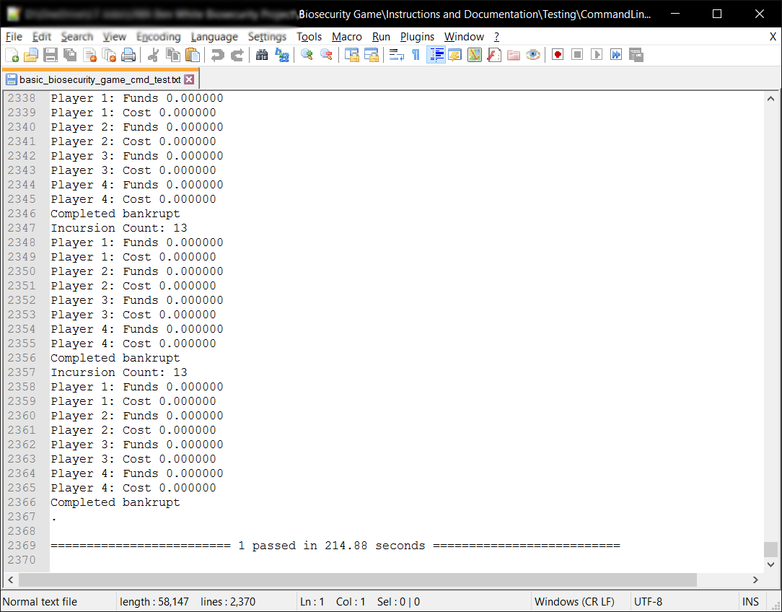

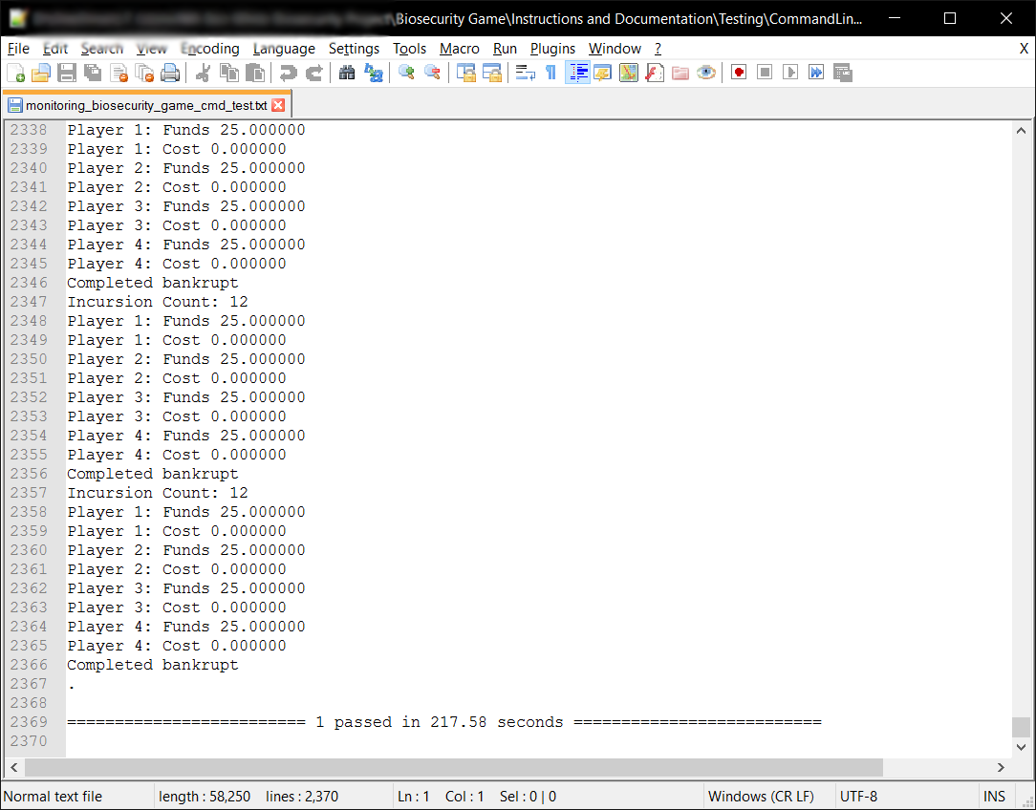

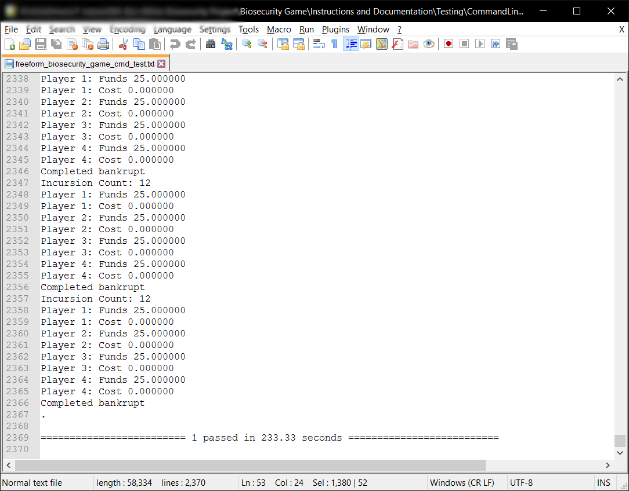

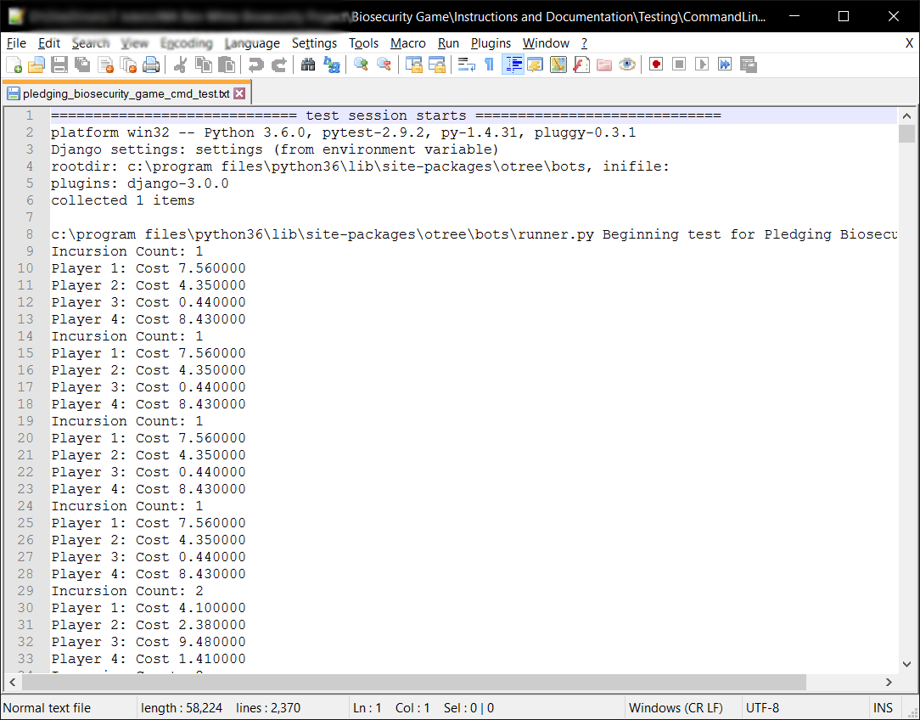

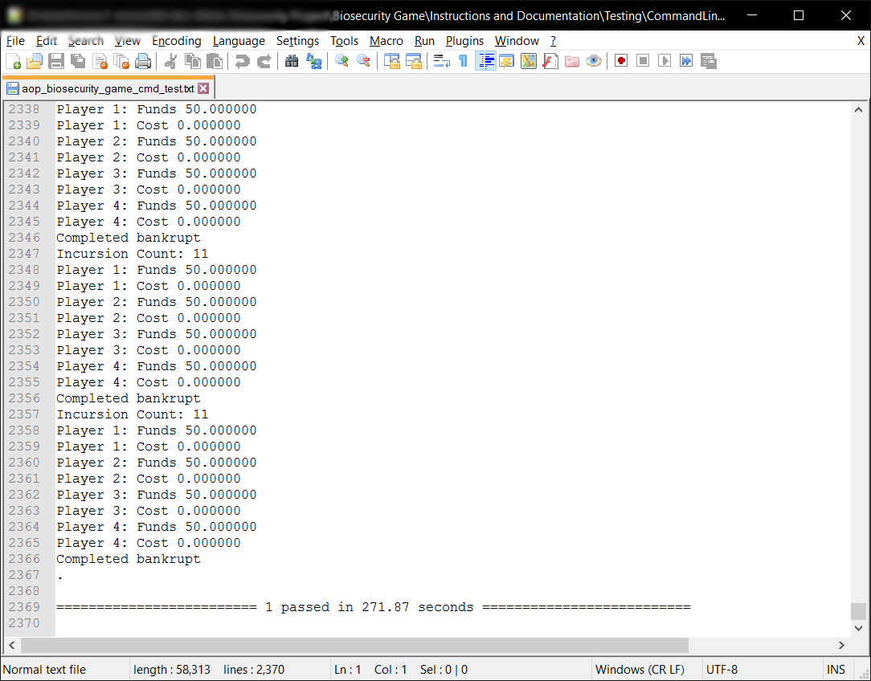

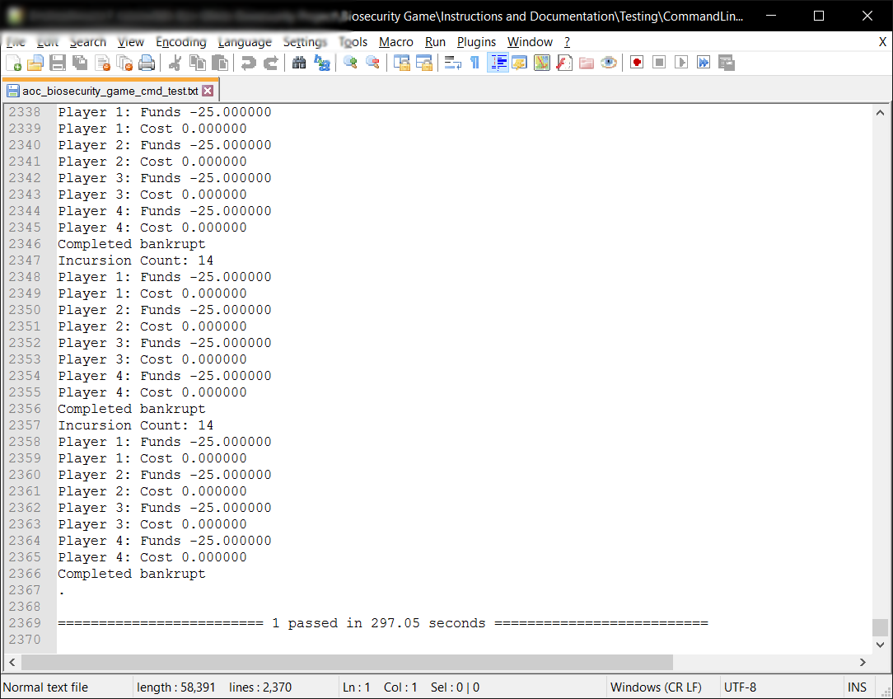

As the above proves, every single test passed and completed without issue.

## Test 3 – Automated Browser Bot Testing

The purpose of this test isn’t necessarily to test the python code or the logic of the game per say, it’s to test the compatibility of Django, Python and oTree across multiple browsers and different devices. This test will reveal any issues the game has with specific web browsers and operating systems. In theory, oTree, Django and Python, and therefore the game should be able to run on any web browser, on any device, or is this the case or not?

### Test Specification

To perform this test, you need to have the following:

1. A web server that has completed the following test Automated Command Line Testing to its requirements. This web server needs to be running the oTree program via otree runprodserver -p 80 (This will run the program and a Daphne web server that will put all input and output through port 80, or HTTP). You can, once you have gained my permission, run this test on biosecurity.are.uwa.edu.au.
2. Ideally you want to have as many different devices as possible, with each device having as many web browsers as you think appropriate. For my testing, I used a Windows 10 PC with Google Chrome, Mozilla Firefox, Opera, Internet Explorer and Microsoft Edge; a Nexus 6P an Android smartphone running Nougat 7.1.1 with Google Chrome, Mozilla Firefox and Opera; an iPad Mini 2 running iOS10.2.1 with Safari, Google Chrome, Mozilla Firefox and Opera. My test covered at least 75% of the market, as Android, iOS and Windows Users use the above web browsers with Google Chrome being the most used browser of them all (Anon., 2017; Anon., 2017).
3. Someway to record the results, you could use oTree’s inbuilt data retrieval. I recorded the results myself through paper and a pen and wrote down any difficulties I had running the tests.

To complete this test successfully, you ideally want to have tested all the browsers you have chosen using the current market share of your time to decide what browsers to test. It is not a requirement of the test that it work on **every** web browser, the **only** requirement is that the test works on the browsers **you wish to support**. In my case I want to support Google Chrome in any version, Safari, Firefox and Microsoft Edge, thus it was a requirement that these web browsers are compatible with the game.

### Test Description

The steps to complete the test are:

1. Navigate to the web site that you are using to test this program, or use biosecurity.are.uwa.edu.au. You could run this locally, in which case navigate to 127.0.0.1:8000, unless you used the -p argument with otree runprodserver in which case navigate to whatever port you assigned for it.
2. 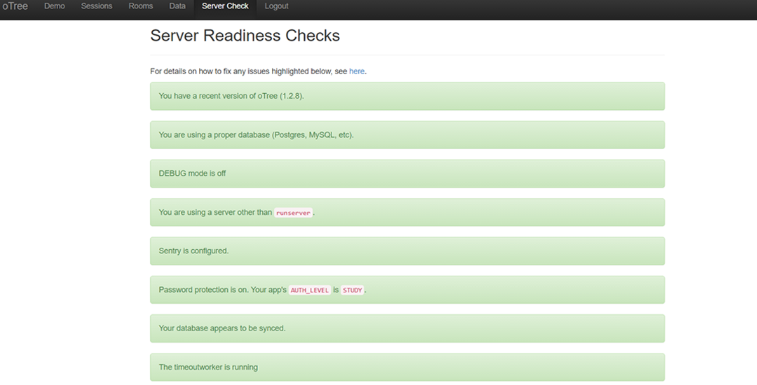Once here, go to ‘Server Check’ located at the top of the administration page and ensure that you are running using the most recent version of oTree (it was oTree 1.2.8 in my case), using a proper database, not using runserver (using otree runprodserver when launching the server), the database must be synced and timeoutworker is running. Observe the following image below, the green details as labelled by red arrows are the required settings to be configured:
3. Now that the server is ready to go, navigate to ‘Sessions’ in the top menu. Here you will be greeted with a list of all the sessions you have created and a button *‘Create New Session’*. Click this button, now select a *Session Configuration*, choose ‘*Basic Browser Bots’* and set the number of participants to 4.
4. Here comes the most important part for testing, click *‘Configure session’*, this will reveal parameters you can change. For testing you must change the case parameter, the case will determine what test scenario it runs, for example, bankrupt will run a case scenario where every player contributes $0 of protection per round in the biosecurity game. Do *‘bankrupt’* as your first case scenario.

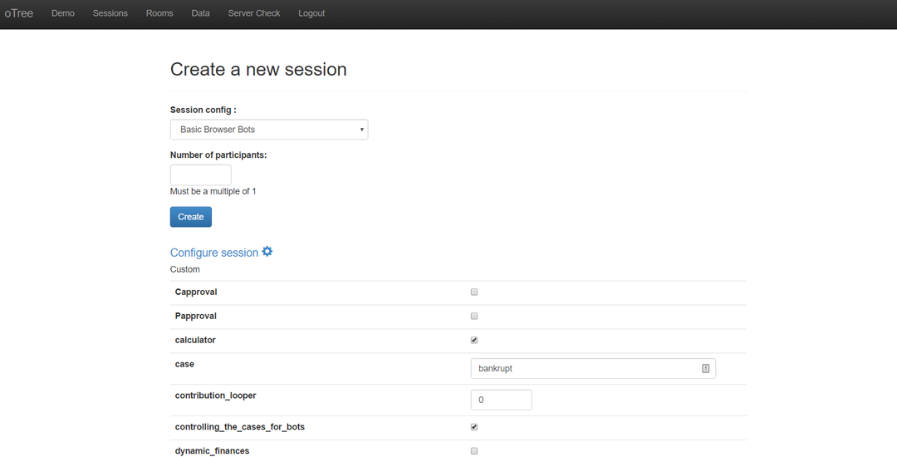

4

1. Create the session and open all the links which will conduct the automated tests in your selected browser. Let them continue until they reach a page where it simply says “*Bot Completed”*.
2. To complete testing for the ‘Basic Browser Bots’, you must repeat steps 3-5, except you must run all these case scenarios successfully (in no specific order and **case specific,** you cannot do **bankrupt** as **Bankrupt**):
   1. bankrupt – Every player does $0 protection every round. You should have just completed this one.
   2. half0halffull – Half of the players do maximum amount of protection, half do $0 every round.
   3. full – Every player does maximum amount of protection every round.
   4. threequarters – Every player does 75% of maximum protection every round.
   5. half – Every player does 50% of maximum protection every round.
   6. quarter – Every player does 25% of maximum protection every round.
   7. random – Every player does a random amount of protection ($0 – Max Protection) every round.
3. Now complete steps 3-6, except choose the following *Session Configurations*:
   1. Freeform Communication Browser Bots
   2. Approval on Pledges Browser Bots
   3. Approval on Contributions Browser Bots
4. Now that you have completed all the Session Configurations, save the data using the Data Export Page. Navigate to ‘Data’ on the top menu in the oTree administration page, and take the excel or csv sheet per app or through all-apps.

The test is completed to its requirements once you have conducted steps 1-8 on the browsers and the systems those browsers are running. This test will take a fair amount of time to complete, here’s some tips to complete it faster:

* You can run one browser bot session and complete the test for multiple browsers by opening (or copying) the links in different browsers across different devices. This is a lesson I learned in doing the manual tests, as iOS only allows 2 active tabs at the same time, meaning that to perform an automated test on an iPad you must constantly switch tabs. This resulted in much manual work for a supposedly automated test, which at the time meant that I didn’t complete the automated testing for iOS and resorted to Manual Testing for the iPad.
* You could create all the sessions first with their appropriate cases, and then proceed to run the browser bots for different cases simultaneously, although, be warned this will cause the web server to slow down. In my testing, which will be examined later, I could run around 20-30 participants or bots simultaneously.
* If the browsers can’t even complete the *Basic Browser Bots* test successfully, chances are they will not complete the rest of the Session Configurations successfully as the other configurations put more stress on the web server and the web browser (and the device its running on) alike.

### Test Analysis Report

In my testing, Windows and Android all completed their tests successfully, iOS had some difficulties as mentioned above, namely that it could only have 2 active tabs. This limitation by iOS on web browsers meant that every time you opened 4 links, only 2 of those links could be doing something in their respective processes. This resulted in me having to switch tabs constantly on iOS, in my case this was too much time to complete the test this way and had to move on to manual testing.

The below tables go through Windows, Android and all the web browsers I tested on these platforms, a tick will indicate that the browser passed the test, and cross will indicate it didn’t. I will explain why each didn’t complete the test appropriately below the tables. As a reminder, the only requirement for the test was for the program to work on any web browsers that the tester (you) wishes to support. To meet this requirement, it needs to *complete every single scenario for each Session Configuration* as mentioned above in the Test Description. Thus, in the tables below, a tick means it completed all the scenarios, in that Session Configuration.

|  |  |  |  |  |
| --- | --- | --- | --- | --- |
| Windows 10 | Basic | Freeform | Approval on Pledges | Approval on Contributions |
| Chrome | ✔ | ✔ | ✔ | ✔ |
| Internet Explorer 11 | 🗙 | 🗙 | 🗙 | 🗙 |
| Microsoft Edge | ✔ | ✔ | ✔ | ✔ |
| Firefox | ✔ | ✔ | ✔ | ✔ |
| Opera | ✔ | ✔ | ✔ | ✔ |

|  |  |  |  |  |
| --- | --- | --- | --- | --- |
| Android 7.1.1 | Basic | Freeform | Approval on Pledges | Approval on Contributions |
| Chrome | ✔ | ✔ | ✔ | ✔ |
| Firefox | ✔ | ✔ | ✔ | ✔ |
| Opera | ✔ | ✔ | ✔ | ✔ |

In these tests, I found all the browsers except Internet Explorer 11 to be compatible with the biosecurity game. The main problem with Internet Explorer 11 was that it occasionally crashed or halted during the test. The game could be restarted after a crash at the point where the game crashed, however this lack of stability was alarming from the start, and even more alarming is Microsoft no longer supporting Internet Explorer. This means users should, if they are concerned about security at all, will abandon the web browser in favour of browsers like Edge or Chrome. Thus, with Internet Explorer 11’s lack of support and instability with the game, I will not support it.

As mentioned, in the Test Description, I didn’t do any automated tests on iOS due to the limitation on web browsers put on by iOS. The limitation was that iOS didn’t allow any more than 2 active tabs at a time. On iOS, this makes sense as it increases battery life with less processor usage, and reduces the amount of data used by the device, meaning people on expensive 3G/4G (and potentially 5G) plans in the future will not suffer large costs. Unfortunately, in this context, it was not helpful and to complete an automated bot test, the tester would have to sit there constantly switching tabs on the device, spending just as much time (or longer) as completing a manual test. To be clear I will support iOS and the web browsers Safari and Chrome, as one will see from the Manual Testing below, they are successful and are quite good at running the program.

Finally, to discuss and compare the behaviour of browsers during these tests, on Windows 10, Chrome and Microsoft Edge were the fastest to complete their automated tests by far. With Opera and Firefox being comparable in speed to each other, but not as fast as Edge or Chrome. Thus, on Windows 10, I will support all browsers that passed all the automated tests, favouring Chrome or Edge. On Android, unsurprisingly, Chrome was the fastest browser, due to Android being an OS developed by Google, Chrome’s optimisation on Android would undoubtedly high priority. Thus, I will support Android’s Chrome Web browser, however I will advise, that people should not play this game on devices smaller than 7”, for an explanation of this refer to the test report for the Manual Testing.

To conclude, Google Chrome is the best web browser for the game to run on, the Manual Testing supports this, as below.

## Test 4 – Manual Browser Testing

The purpose of manual testing is to observe how the game behaves in real time, to see if the manual testing reflects the results of the automated browser bot testing. The tests also include any actions coming from administrators like moving the slowest players forward, checking the data as games progress. Mainly this test is about how the game looks and works on many different devices and browsers. It is this test that is the final stage of testing the game itself, ensuring that its working in all areas as it should.

### Test Specification

This test has the same specifications as Automated Browser Bot Testing, like that test you need to ensure it passes the test on the browser and devices you wish to support. To pass the test, the game must perform the following the requirements:

1. Complete the Lottery Game, perform at least 5 rounds of the Biosecurity Game, and display the results and Questionnaire properly at the end, with ***absolute success***, there must not be a single issue by this point.
2. The administrator must be able to use the ‘move slowest players forward’ functionality for at least 5 rounds of the Biosecurity Game.
3. The administrator can check the data while the game continues and the game dynamically updates the data appropriately, including the Payments Page.
4. To have met the previous 3 requirements in the Session Configurations:
   1. Basic Biosecurity Game
   2. Freeform Communication Game
   3. Approval on Pledges Game
   4. Approval on Contributions Game
5. Finally, have met requirements 1-4 on each device and all the browser you wish to support on that device

The browsers and devices I tested on are the same as the Automated Browser Bots Tests.

### Test Description

The steps to complete this test are as follows:

1. Navigate to the same website/server that you used to perform the Automated Browser Bot Testing, in my case this was biosecurity.are.uwa.edu.au. Also like the browser bot testing, ensure the server is still healthy as per step 2 here.
2. Navigate to ‘Sessions’, and click ‘Create a new session’. Now in the list of Session Configurations choose ‘Basic Biosecurity Game’. Like the browser bot testing, put 4 as the number of participants and click create. Here there is no need to configure the session like the browser bot testing as we do not need to change any variables to test the game in its ‘default’ states as per the Session Configurations.

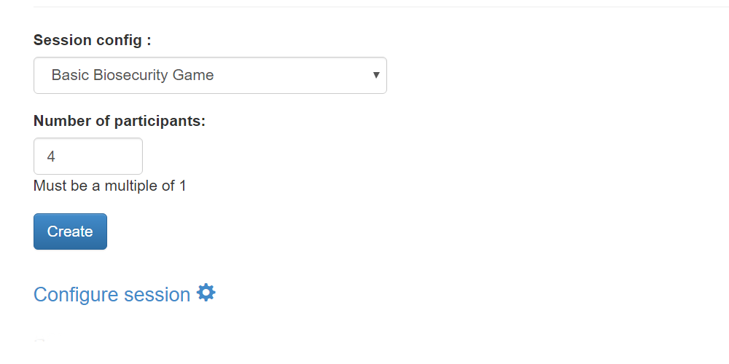

1. Now, here is when you have options as to how to perform the test, each will give you the same result even if there are issues. The first option is on each device and each browser, open the 4 links for every participant in new tabs on that one browser, meaning you will test each browser one by one with a full game. This is very time consuming, so my suggestion is to do a new browser for every player as per the following example:  
   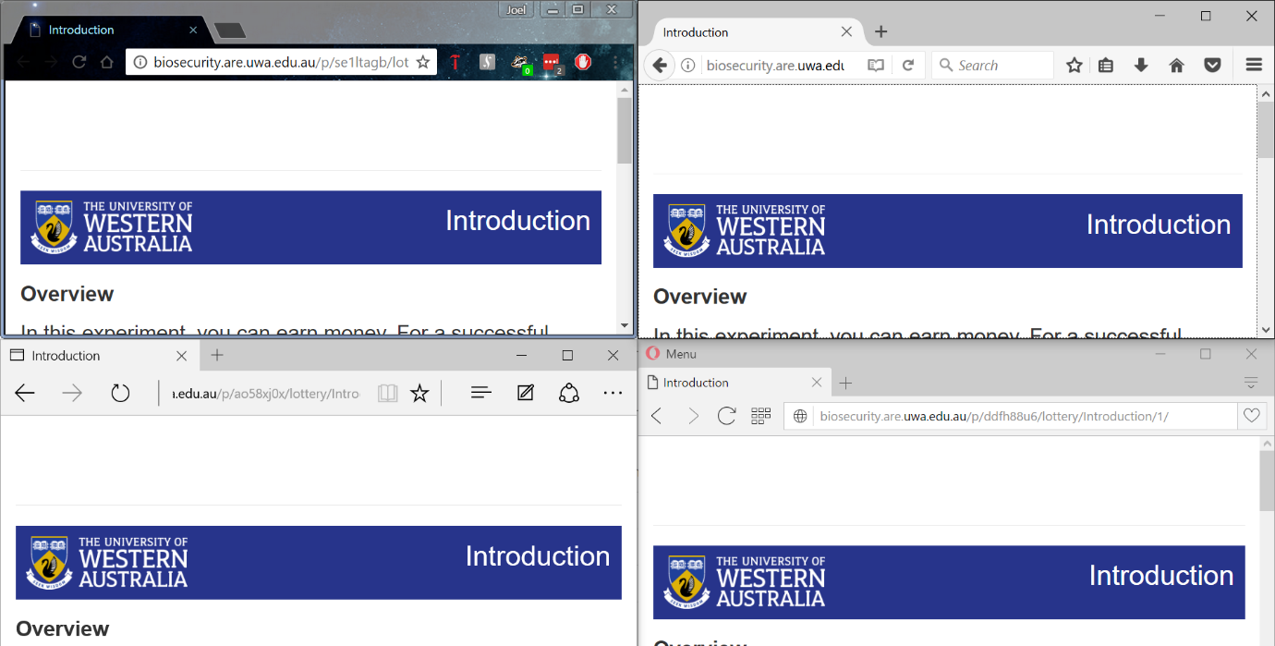

This method will allow you to complete your tests more quickly and more efficiently, with a bonus of testing how browsers and devices interact with each other in a real world like scenario.

1. Now play the Lottery Game, and the first 5 Biosecurity Game rounds yourself, in each round you must use different numbers in a random sequence to identify that the functions and algorithms work. To ensure that the calculations are working perfectly, use the first round of the Biosecurity Game as a chance for every player to do $0 or the maximum amount of protection to get expected and verifiable results. Test every slider, every button, observe how the elements look on screen (does font become unreadable on certain devices? Are the pictures too big for certain browsers or devices? Do the sliders work properly alongside the JavaScript that accompanies them? Etc.) ensure that the right information appears based on how you made the players play the game, for example in the instructions we don’t want chat instructions appearing when we aren’t in the Freeform Communication Game session configuration.
2. Once you have completed 5 rounds yourself, check the ‘Monitor’, ‘Data’ and ‘Payments’ page, ensure that each page displays the correct information. The ‘Monitor’ page should show which page each player is currently on and how long they’ve been on the page. The ‘Data’ page should show the data for the game as it progresses, ensure the data for the Lottery Game is there and that the first 5 rounds of the game have been recorded on the data page. The ‘Payments’ should show how much each player is owed as per the conversion rate and participation fee for the game, this page also dynamically updates with the game. Observe the following images below as to what the pages look like.  
   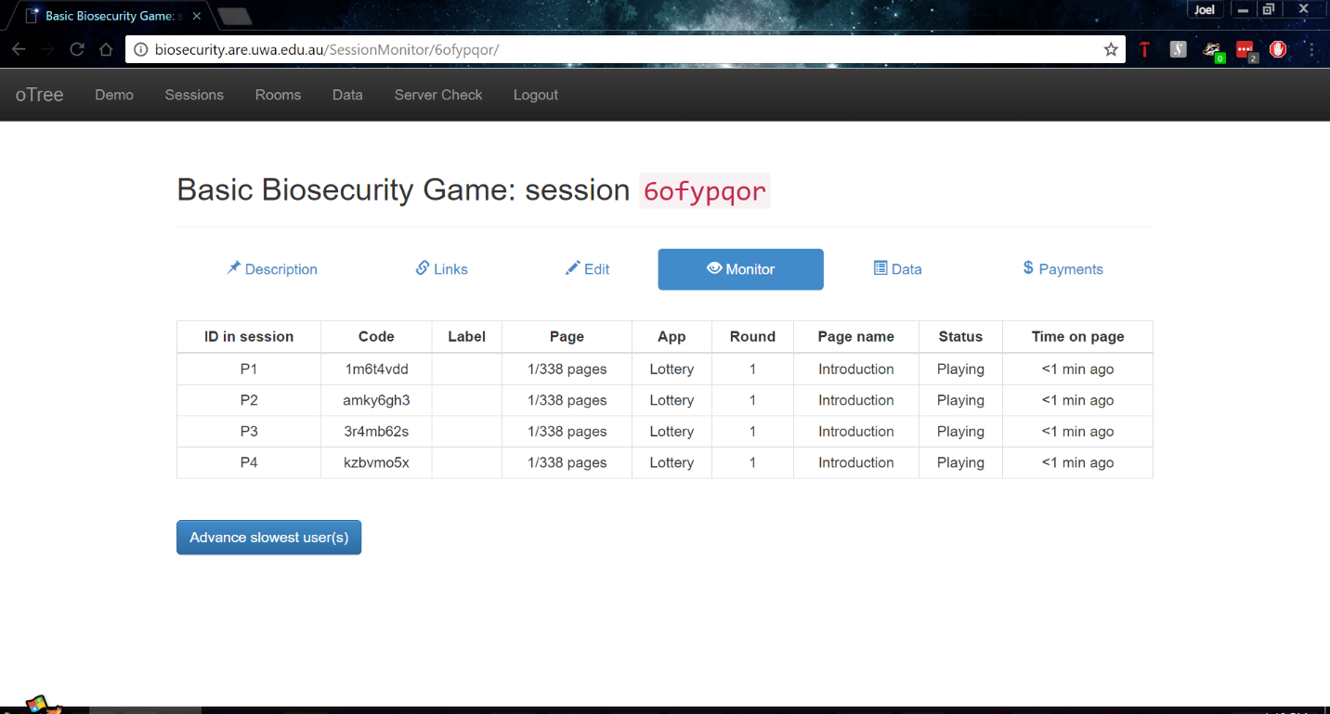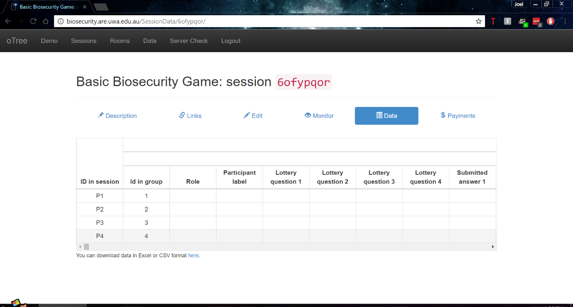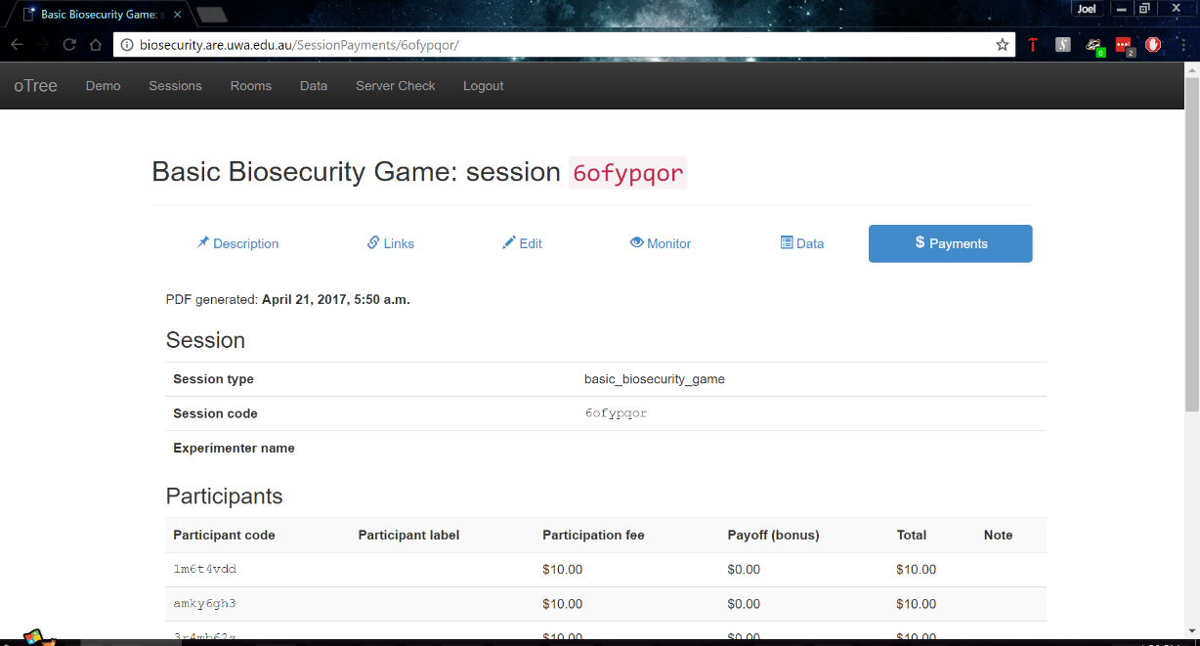

1. Navigate back to the Monitor page, you should see that everyone has probably advanced a few pages while you were performing step 5. If they’re all still at the same page you left them and didn’t advance even a single page, then the timeouts might not be working as expected. If they did advance then continue the test by clicking ‘Advance slowest user(s)’ as seen on the ‘Monitor’ page, assuming you have completed all tests properly so far, clicking this will advance every user to the next page. You are to keep advancing every player till every single player reaches round 11, you will notice that not every player seems to be on the same page according to the monitor page, don’t worry, the monitor page is slower to update than the game, chances they are on the same page, the monitor page just needs to catch up.
2. Now that you’re at round 11, perform the same checks as you did in step 5, ensure that the Data and Payments pages have updated accordingly.
3. Now complete the game youself, complete the questionnaire and when it reaches the final page that shows the result for the entire game, verify that the results reflect what it says on the Data page.
4. Label the session with the session configuration it was and what devices and browsers you used to test it, this will show up when you extract all the data at the end. For example:  
   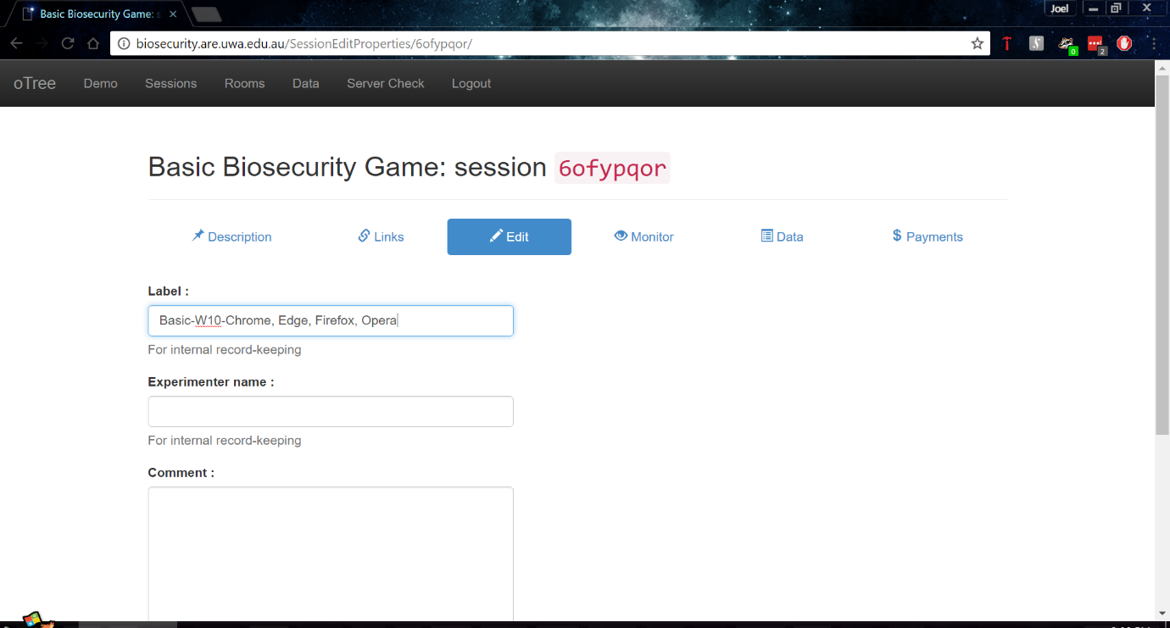
5. Now repeat steps 1-9 till you have tested all the session configurations as mentioned in the Test Specification on every device and browser you wish to support.
6. Finally, once you completed steps 1-10 now extract the data using the ‘Data Export’ page and clicking ‘Excel’ inside the ‘All apps’ section. This will download an excel file with every single session configuration you tested, and if labled your sessions you will have proof that you completed the tests on your devices, and browsers.

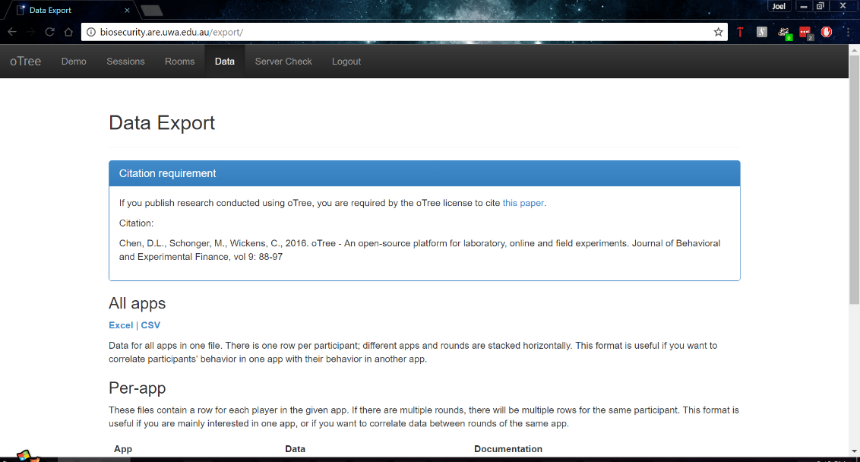

### Test Analysis Report

<<The Test Analysis Report lists the functions and performance characteristics that were to be demonstrated, and describes the actual test results. The description of the results must include the following:

* Function
* Performance
* Data measures, including whether target requirements have been met

If an error or deficiency has been discovered, the report discusses its impact.>>

**Test 5 – Server Performance**

<<Introduction and overview for test D>>

**Test Specification**

<<The Test Specification lists the requirements whose satisfaction will be demonstrated by the test. It lists the methods tested, and describes the conditions of the test.>>

**Test Description**

<<The Test Description is used as a guide in performing the test. It lists the input data and input commands for each test, as well as expected out put and system messages. If you find that you are unable to describe expected output numerically, use a natural language description. A test description consists of

* Location of test (hyperlink to test)
* Means of Control: Describes how data are entered (manually or automatically with a test driver)
* Data
  + Input Data
  + Input Commands
  + Output Data
  + System Messages
* Procedures: The test procedure is often specificed in form of a test script.

**Test Analysis Report**

<<The Test Analysis Report lists the functions and performance characteristics that were to be demonstrated, and describes the actual test results. The description of the results must include the following:

* Function
* Performance
* Data measures, including whether target requirements have been met

If an error or deficiency has been discovered, the report discusses its impact.>>

**Test Materials**

The test materials required will be a PC (Linux, Windows or OSX, Windows preferably as the other devices have browsers can have those that OSX and Linux can have, while Windows has IE and Edge), Android Smartphone or tablet, and an iOS phone or tablet. With these 3 devices one will be able to test web browsers that will be used by most participants including Chrome, Firefox, Internet Explorer 11, Safari, Microsoft Edge and Opera. The server will need to be on during the testing period, however one should not have to worry about the server being on due to it being on 24/7 except for about 5 mins in the middle of the night once a week.  
  
Theoretically, the game should work no matter what OS you’re running on your own personal device as the Server runs all the python code and produces the Django templates which your web browser views as HTML. However, to be thorough, each device should have as much web browsers as possible for testing.

## oTree_Tags

For this program to work you will need to adjust the oTree package files, as this program requires an adjusted otree_tags file. There are two ways you can do this:

1) Assuming you cloned the repository or have the program files available to you, inside the Lottery app folder named *Lottery*, there should be a directory named otree_tags, go in there.  
Copy the otree_tags file inside a paste the file inside this directory:

<Home>\Python<version>\Lib\sitepackages\otree\templatetags\  
  
<Home> refers to your account files and folders which will be located differently depending on your OS, please refer to the Python documentation and how you installed Python on your machine to find the directory we’re looking for. Also, keep in mind the folder will be named differently depending on your Python version, so refer to what version you have as well to fill in <version>.

2) Instead of copying the file in the repository, find this file below (refer to above to understand what <Home> and <version> mean):

<Home>\Python<version>\Lib\sitepackages\otree\templatetags\otree_tags.py

In this file add the code as per the image below:

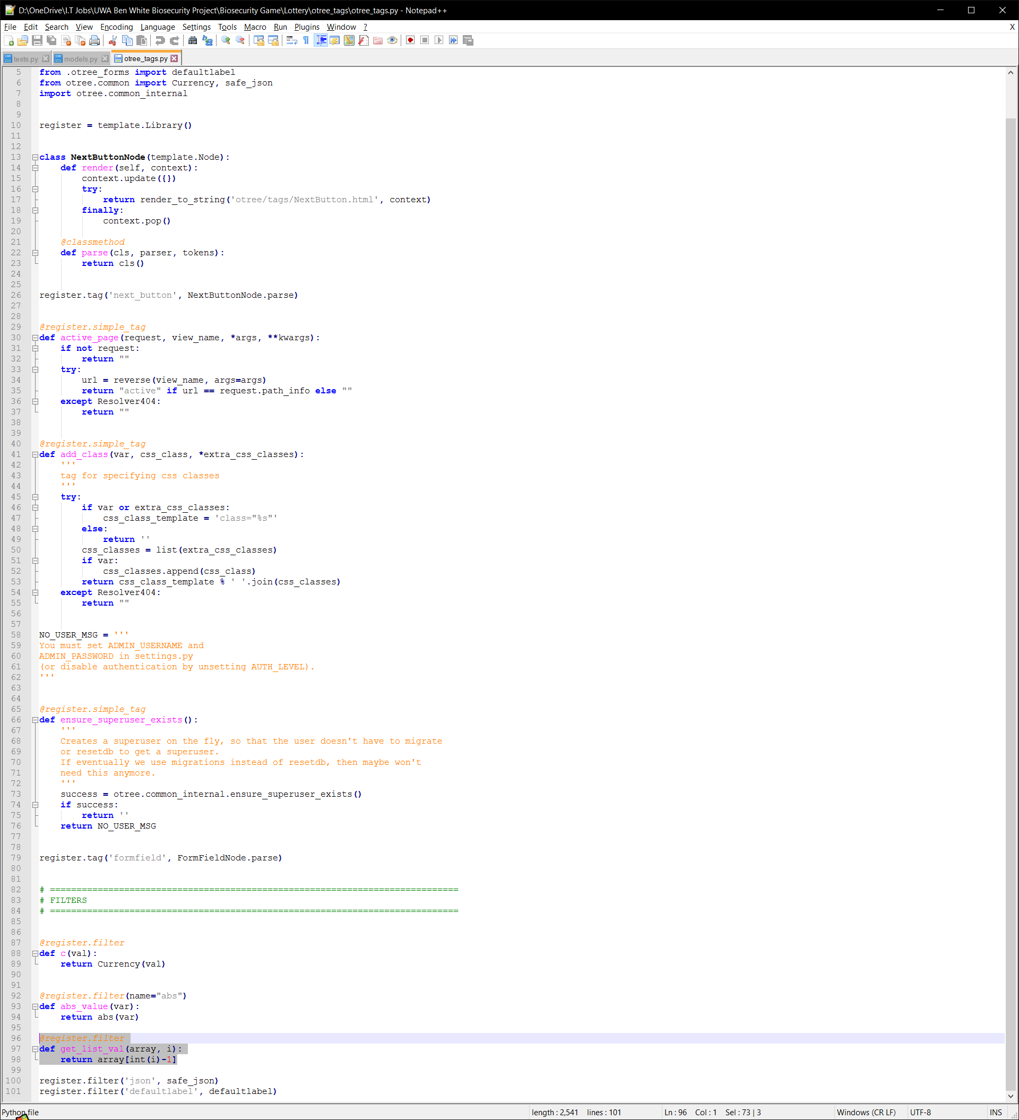

# **Glossary**

# References

Anon., 2017. *Net Market Share.* [Online]   
Available at: https://www.netmarketshare.com/  
[Accessed April 2017].

Anon., 2017. *W3 Counter.* [Online]   
Available at: https://www.w3counter.com/globalstats.php  
[Accessed April 2017].

1. These averages were the combined average of the 4 players at Round 5, for more detailed results on how each player performed refer to the Excel Spreadsheets or perform your own.
2. Same as 1
3. These averages were the combined average of the 4 players at Round 5, for more detailed results on how each player performed refer to the Excel Spreadsheets or perform your own.
4. Same as 3